1. Directed Graph

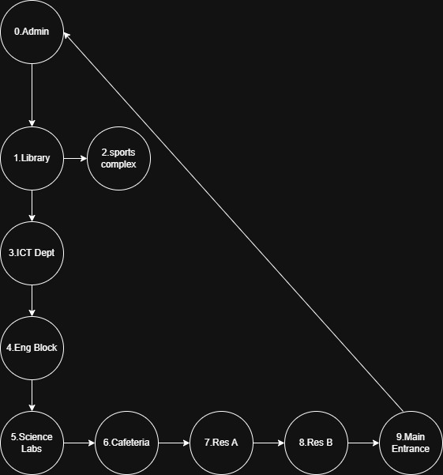

2.Adjacency Matrix

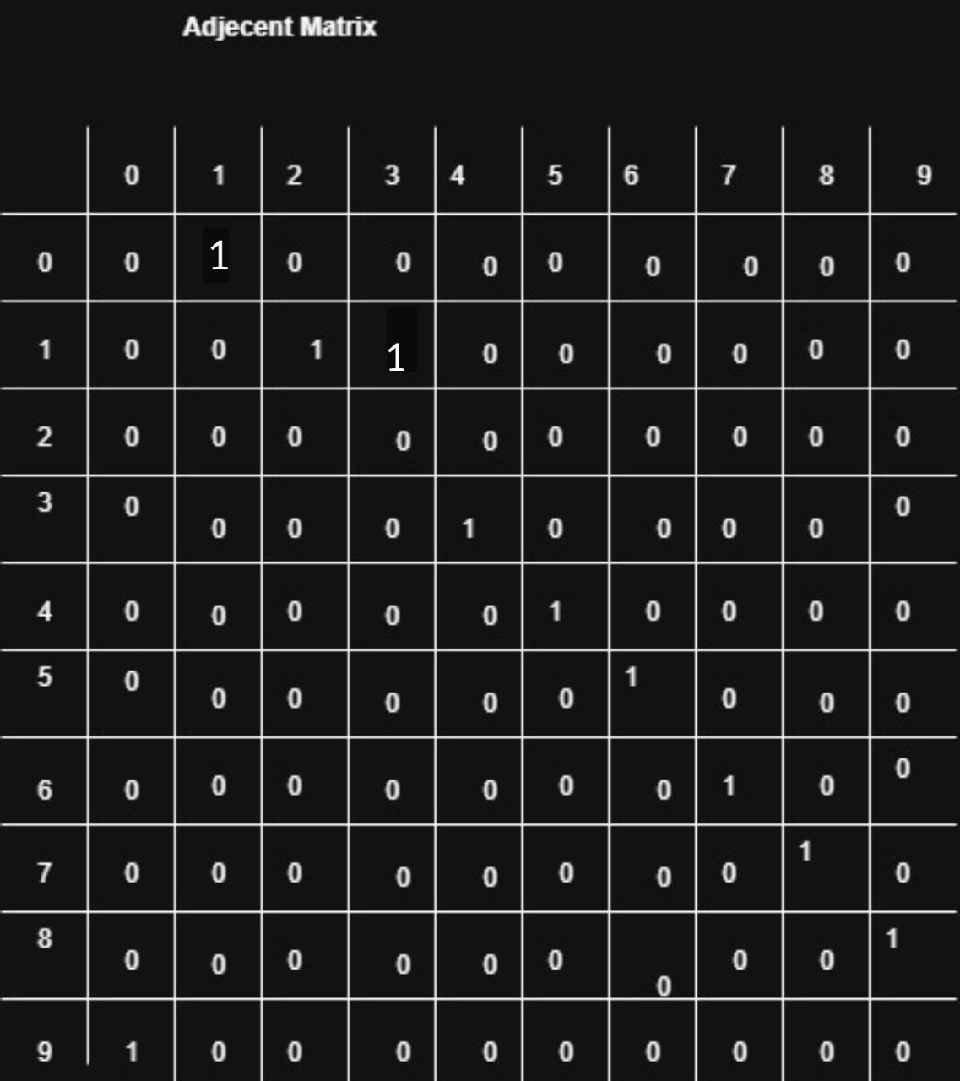

1. Hash map

adj_list = {

"Admin": ["Library"],

"Library": ["ICT Dept", "Sports Complex"],

"ICT": ["Eng Block"],

"Engineering": ["Science Labs"],

"Science": ["Cafeteria"],

"Cafeteria": ["Res A"],

"Residence A": ["Res B"],

"Residence B": ["Main Entrance"],

"Main Entrance": ["Admin", “Admin”],

"Sports": []

}